FORMAT OF BIODATA

Name: Ms. Patange Bharati Vasant  Address: Ganesh Colony, Rupeenagar  Tal-Haveli, Dist-Pune  Pune-411062 | 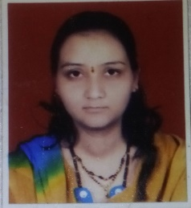

Designation: Lecturer

Educational Qualification: M.C.A., M.B.A.

Teaching Experience: 11 Years

Classes Taught: FYBBA(CA), SYBBA(CA), TYBBA(CA)

Faculty development programmes (Orientation/ Refresher/ Short term courses): -NIL

Research Area: -NIL

Research Projects:-NIL

Research Articles published In Journals: NIL

Paper presented in International Conference: NIL

Paper presented in State level: “Challenges before Women Entrepreneurs in India” at
Prof. Ramakrishna More Arts. Commerce and Science College Paper Topic: “Empowering of Women Entrepreneurs challenges and disadvantages”

Awards/Honours: NIL

Books Published: NIL

Innovations in Curriculum design and transactions: NIL

Resource Person: NIL

Seminars/Workshops/ Training courses attended: Workshop on “Importance of Physical Educations”

Participation in community/ Social Services: Organized “E-Literacy” Program at Yelghol village

Memberships on various bodies: NIL

Computer Skills: MS-Office, Computer Languages .

